**#Grazioso Salvare Rescue Animal Dashboard**

**##Tanner Hunt**

**##June 18, 2025**

**##SNHU CS340 Client/Server Development**

**#Purpose**

This is code written for Grazioso Salvare, an animal rescue training company. This data dashboard pulls records from animal shelters to help identify potential dogs to train. Because this can benefit many people, the project is being left open to the public.

**#Functionality**

This dashboard will display a paginated list animals found in shelters around the Austin, Texas area. There are additional filters to show animals that would be good candidates to train for water rescue, mountain and wilderness rescue, and disaster and individual rescue. The shelter locations are shown in a map, and the spread of breeds for the dog are displayed in a pie chart. These functions are shown below:

*Landing Page*

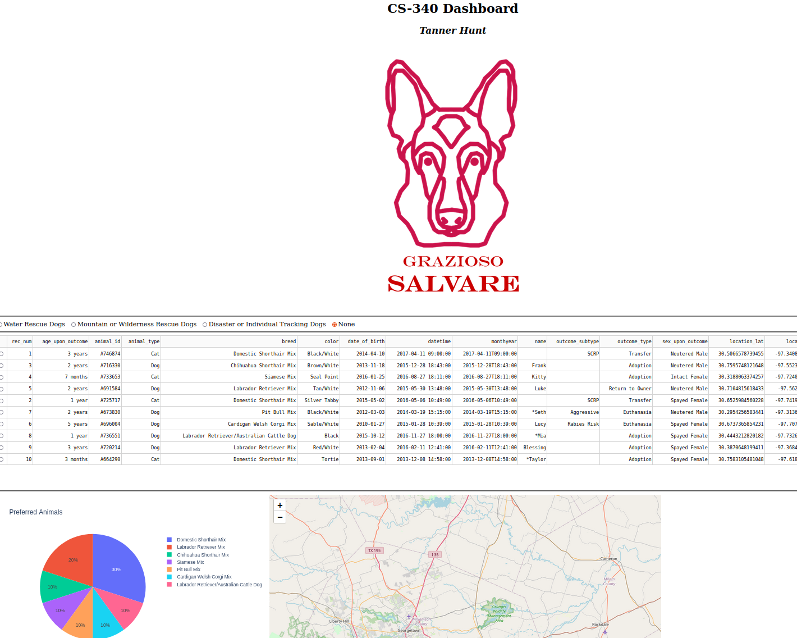

*Water Rescue Dogs*

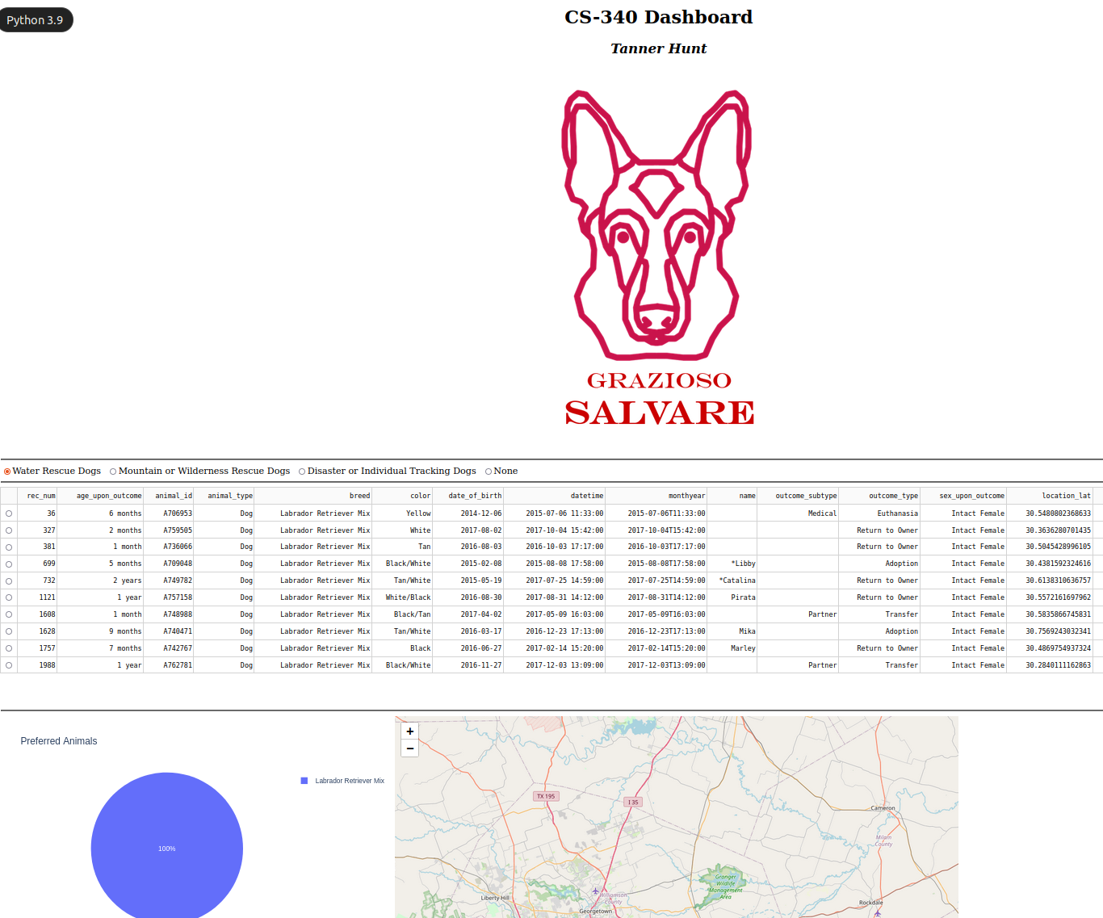

*Mountain and Wilderness Rescue*

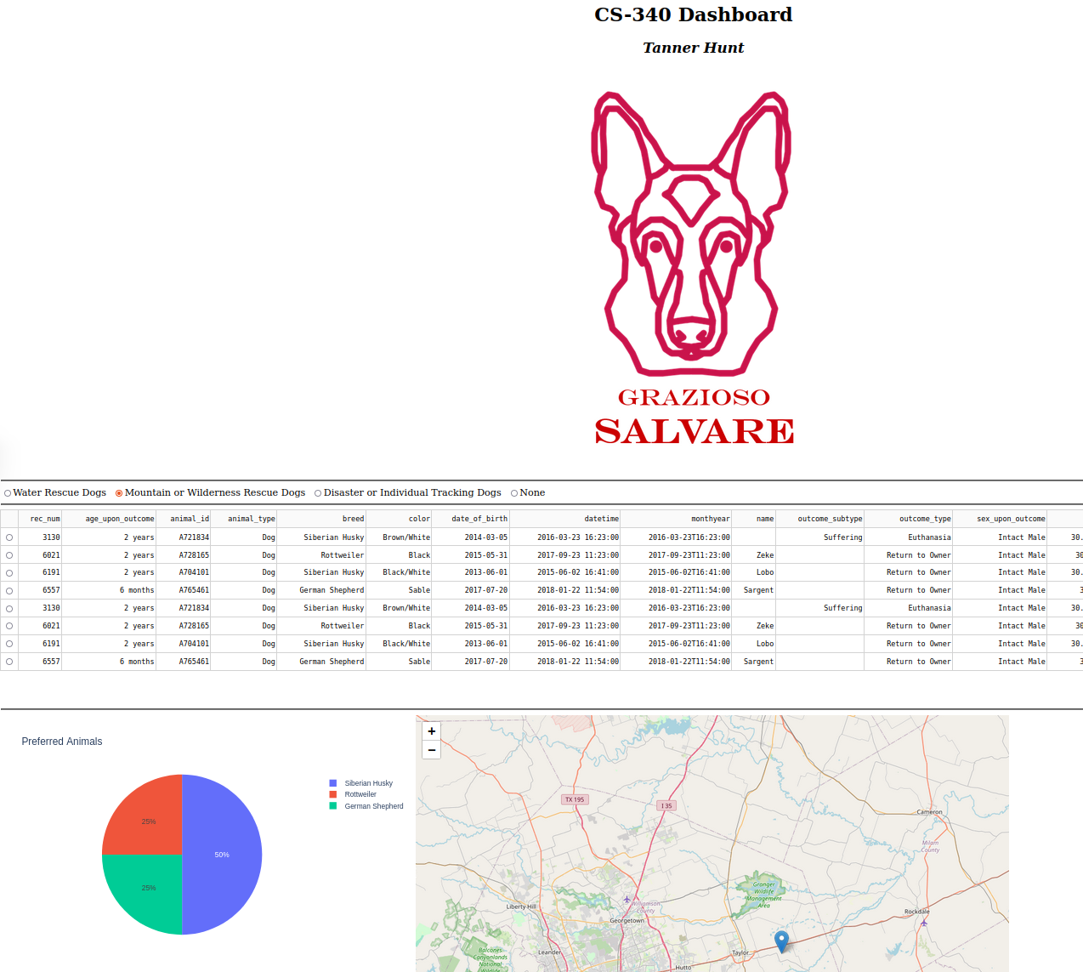

*Disaster and Individual Rescue Dogs*

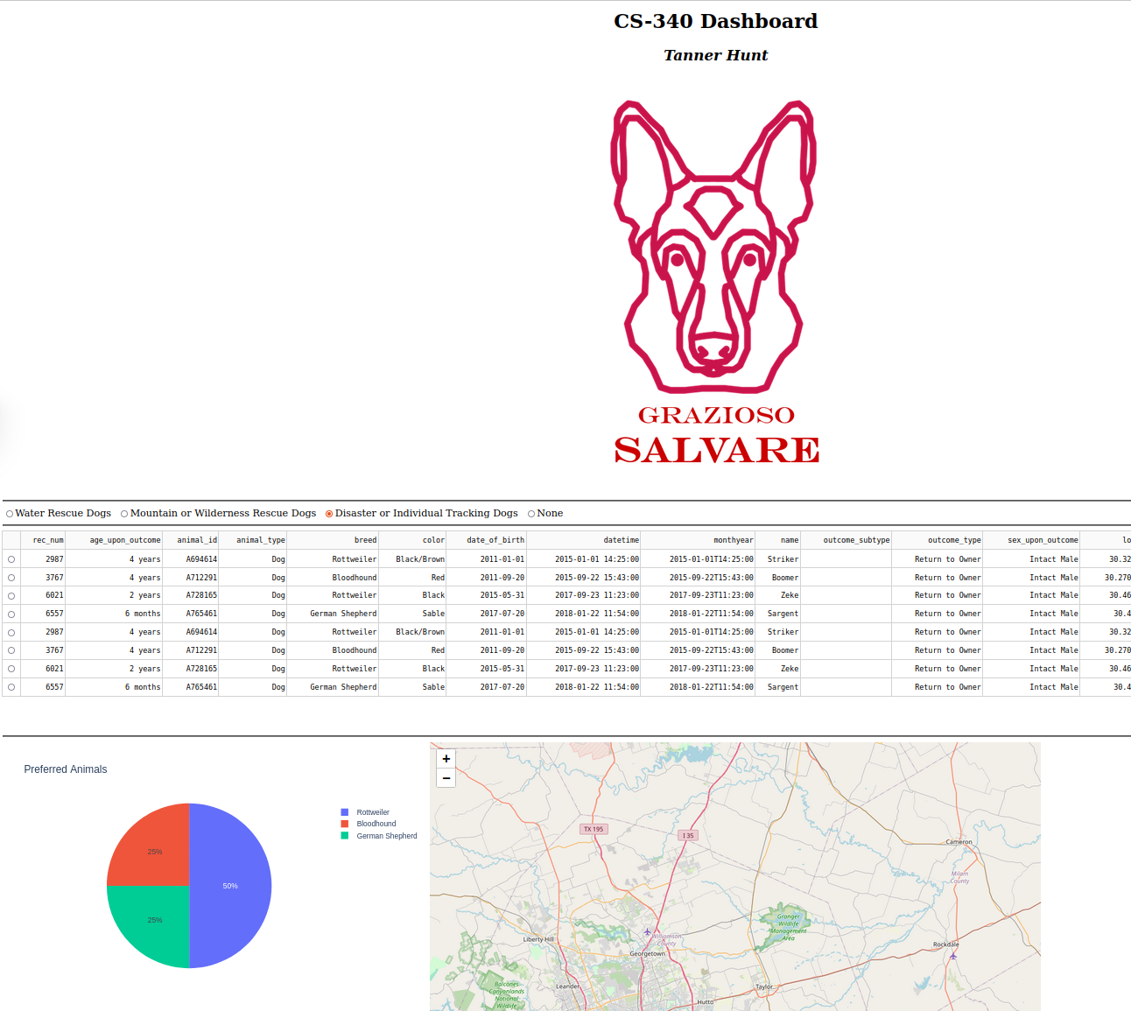

**#Reproduction**

To reproduce this dashboard:

* Download the three files included in this project folder (AnimalShelter.py, ProjectTwoDashboard.ipynb, Grazioso_Salvare_Logo.jpeg)
* Upload all three files to JupyterNotebook, in the same folder
* Run the ProjectTwoDashboard.ipynb notebook
* Open the linked web page

**#Technology Stack**

* This project uses MongoDB as it’s database (<https://www.mongodb.com/>)
  + MongoDB was a good choice for this database because it has fast indexed lookup times and some documents fields may differ from one another.
  + MongoDB also interfaces with python using it’s native drivers (<https://www.mongodb.com/docs/drivers/python-drivers/> )
* The “Dash Framework” controls both the data view and the data controllers (<https://dash.plotly.com/> )
  + This framework makes generating HTML and visual components faster and easier
  + This framework also helps update components when changes are made. For example, the map, graph, and data table when animals are filtered by potential jobs.
* Jupyter Notebook (<https://jupyter.org/> ) provides a modular development environment that this code runs in
  + Using a jupyter notebook is required to use the ProjectTwoDashboard.ipynb file
  + This will also run a website on your localhost

**#Process and Challenges**

## Steps taken to complete this project

* Many components in this project were a culmination of work that has been done in previous weeks. Those steps will not be detailed here
* Previous code was imported into the projects template
* The logo for Grazioso Salvare was downloaded into Jupyter Notebooks and imported into the project
* Using the Dash Framework Documentation, I created radio buttons for the different filter options
* The Data table callback was updated so that it called the appropriate fetch request from the database
* The pie chart callback was coded in to display that graph.

## Challenges to this project

I initially had difficulty deciding how to handle the radio button callback. This was mostly due to being disoriented in the project – it’s a monolithic file structure and jupyter notebooks doesn’t have good navigation features. After some trial and error, I found the best place was to modify my previous callback, update_datatable_page, and grow it’s functionality to both filter the data table and paginate the table.